|  |
| --- |
| Home |
| **Signal Detection Tracker (SigTRACE) 1.0** |
| User Manual |
|  |
| **Kamlesh Narayankar** |
| **12/June/2017** |

# Document History

|  |  |  |
| --- | --- | --- |
| **Action** | **Version** | **Date (DD-MMM-YY)** |
| Initial Release | 1.0 | 12-June-2017 |

Introduction: 4

Benefits of SigTRACE include: 4

Roles and Access: 5

Login 6

Import (Role: Initial Assessor) 8

Quantitative Analysis Workflow – review by DSL: 13

Qualitative Analysis Workflow (Role: Initial Assessor, QC and DSL) 15

Qualitative Analysis 19

Quality Check (Role: Quality Reviewer) 21

DSL review of qualitative analysis (DSL role): 24

Signal Detection Summary (Role: Quality Reviewer or DSL): 28

Validation (DSL): 31

Report generation 37

**SigTRACE Tool**

# Introduction:

SigTRACE is a consolidated, end-to-end signal management tool that manages and tracks signal detection validation, analysis, prioritization, assessment, recommendation for action and exchange of information. SigTRACE integrates indirectly with the safety database to help manage the entire signal management process.

# Benefits of SigTRACE include:

Consolidates and tracks all parts of the signal management process (signal detection, validation, analysis, prioritization, assessment and recommendation for action) into one tool, providing a clear overview of the entire process

Integrates indirectly with the safety database, providing efficiencies (eliminating manual extraction) and ensures that data used for the signal management process originates from a validated source and is not prone to corruption

Semi-automated features for detection, form validation checks, reports and notifications including:

**Signal detection** – workflows to screen for safety observations and perform initial evaluations on them

**Signal validation** – workflow to decide if the safety observation is a potential signal or not. Based on this, a signal is either validated or not validated. Prioritization is also done as part of this process.

**Signal assessment** – workflow to further track the assessment of the validated signals to establish the causal relationship (outcome of signal: rejected or confirmed) or to identify the need for additional data collection (outcome of Signal: undetermined signal). A customized report can also be generated to assess these signals. Depending on the outcome various **Recommendations for action and communication** are captured.

Generates comprehensive reports to ensure the entire process is managed appropriately – If findings are discovered, SigTRACE has the data to identify the specific break in process.

Replaces the traditional mix of disparate processes, environments, databases and tools associated with signal management

Most of the data is stored within SigTRACE, reducing the need for separate database or file storage repositories.

# Roles and Access:

|  |  |  |  |  |  |  |  |
| --- | --- | --- | --- | --- | --- | --- | --- |
|  | **Signal Detection** | | | | **Validation and assessment** | | |
| **Quantitative analysis** | **Qualitative analysis** | | | **Signal detection summary** | **Validation** | **Assessment** |
| **Qualitative analysis** | **Quality check** | **DSL review** |
| **Initial assessor** | Yes | Yes | No | No | No | No | No |
| **Quality reviewer (QCer)** | Yes | Yes | Yes | No | Yes | No | No |
| **Drug safety lead (DSL)** | Yes | Yes | No | Yes | Yes | Yes | No |
| **Drug safety lead Assessment** | No | No | No | No | No | No | Yes |
| **Administrator**  **(Access control)** | No | No | No | No | No | No | No |

# Login

1. Login to the tool at “https://sigtrace.synowledge.com” using the assigned username and password.

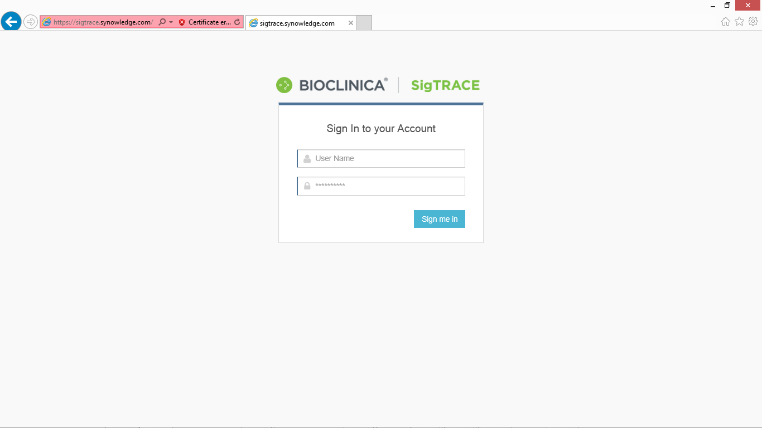

**Click “Sign me in”**

**Enter User name and Password**

After successful login, you will be directed to the home page which will display a dashboard.

**Dashboard view:**

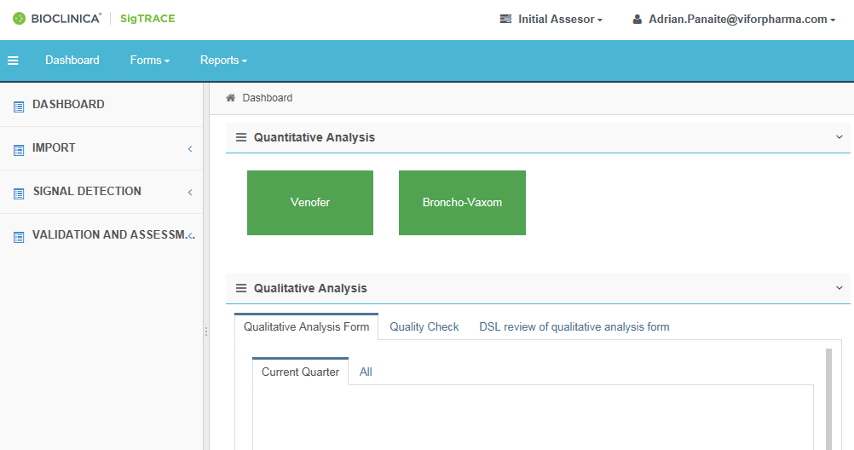

**1. Click on Dashboard for homepage**

To view the homepage, click on the Dashboard on the top horizontal zone

The dashboard contains 4 Main headings on the left column and display page. By selecting the headings, the content of the right side of the dashboard will display the relative page. Information is displayed Product wise (e.g.: Venofer, Ferinject), quarter wise (Current and All).

1. **Dashboard**
2. **Import (accessible by Initial assessor)**
   1. **Import Data**
   2. **Sample Import file**
3. **Signal Detection**
   1. **Quantitative analysis**
   2. **Qualitative analysis**
      1. **Case Information**
      2. **Qualitative Analysis form**
      3. **Quality check**
      4. **DSL review of Qualitative analysis**
4. **Validation and Assessment**
   1. **Signal Detection Summary**
   2. **Validation**
   3. **Assessment**
5. **Frequency analysis: Workflow inactive in version 1, accessible by DSL users**
6. **Fatal cumulative analysis: Workflow inactive in version 1, accessible by DSL users**

# Import (Role: Initial Assessor)

The Import heading has the following subheadings: Import Data and Sample Import file for reference. The necessary steps to perform each action are detailed below.

* Request data from the AIMS team and convert the received file(s) from .xls to .csv (save as).
* Verify that the fields to import match the required ones from the Sample Import file
* After clicking on Import there will be a page showing ‘Import Data’. SigTRACE V 1.0 has the provision to import data file in .csv format.

**SigTRACE files import**

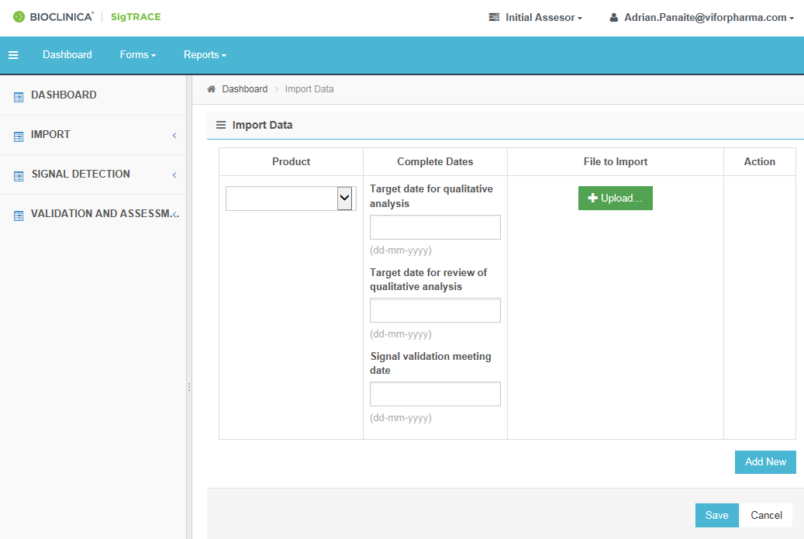

1. **Click Import Data”**

**2. Select the product from the dropdown list**

**5. Enter the SD meeting date**

**4. Enter the target date for completion of QC activity as per SD calendar**

**8. Click on “Save” to import file**

**7. Click on “ADD NEW” to add another file**

**6. Click on Upload and browse to file for uploading**

**3. Enter the target date for completion of activity as SD calendar**

* Follow steps 1 to 8 as described in the image above.

1. To import the .csv file into SigTRACE; first select the products from the ‘products’ drop down list.

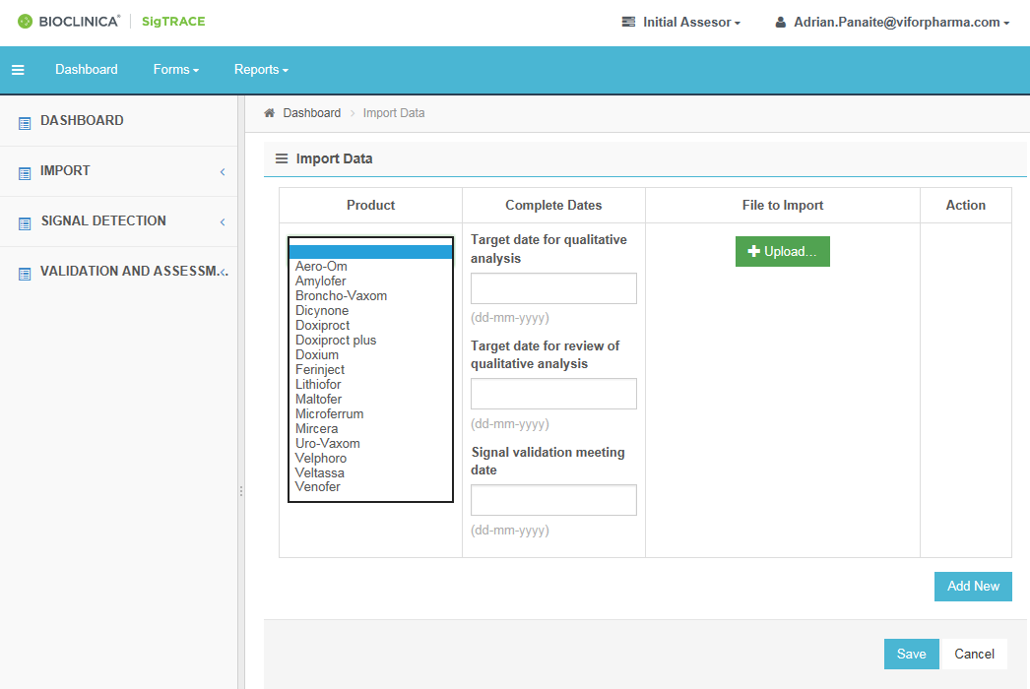

**Select “Product” name from the drop-down list**

1. Enter Target date for Qualitative analysis, Review of Qualitative analysis and Signal Validation meeting date from the calendar pop out.

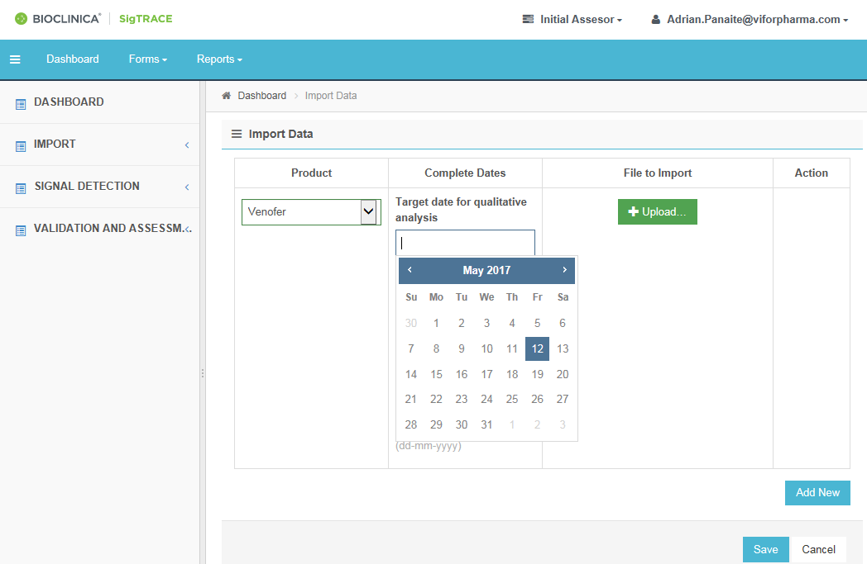

**Select the date from the calendar**

1. Upload File:

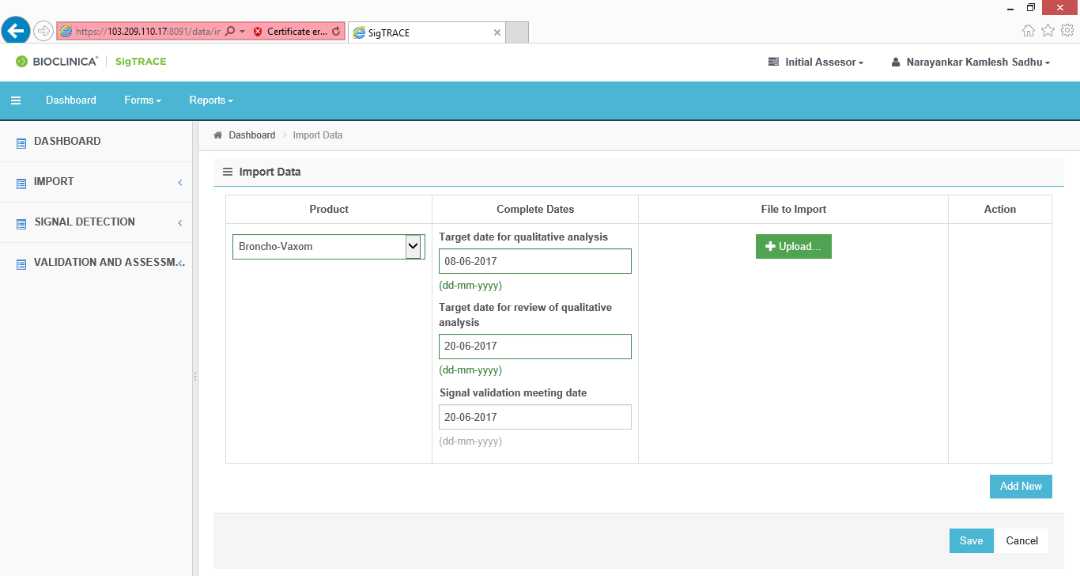

**Select “Upload” to browse to the CSV file**

* 1. Click on ‘Upload’ option to import file.
  2. Select ‘CSV file’ from local drive from the pop out window.

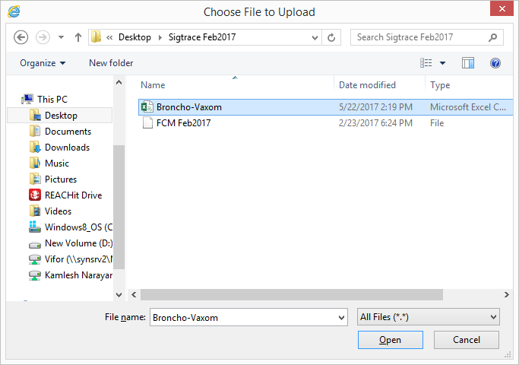

**Click on Open to import the selected file**

**select the CSV file to be uploaded**

* 1. Select ‘Add New' to import multiple files at a time. After adding each row, repeat steps 1 and 2 to import files.
  2. Finally click on the option ‘Save’ to import the files in SigTRACE.

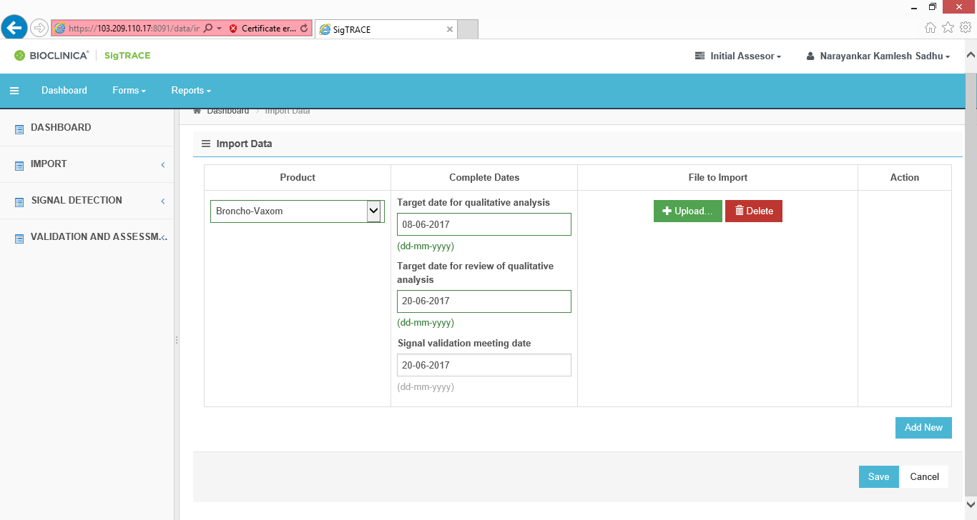

**Click “Save” after all rows are added**

1. The imported results will appear in the Quantitative workflow product panel on the dashboard.

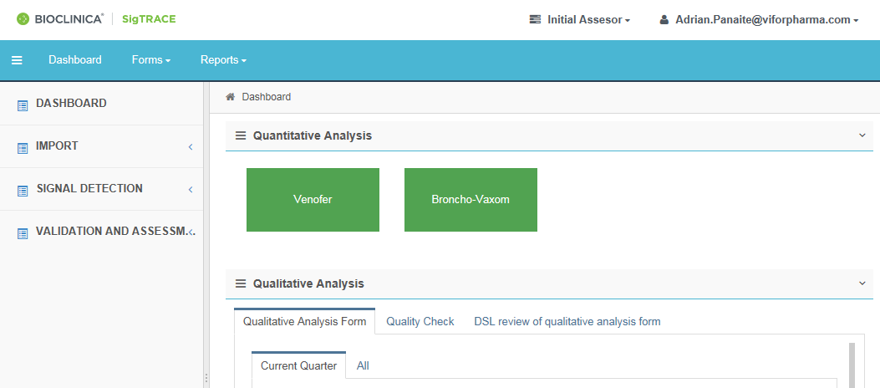

**Displays the result (product name) after importing file**

# Quantitative Analysis Workflow – review by DSL:

* Once the file(s) is(are) imported Successfully, SigTRACE will display information on dashboard as per product and Quarter.

1. To open Quantitative workflow for particular product, click on the product name under Quantitative Analysis tab on Dashboard



**Product name**

**Workflow**

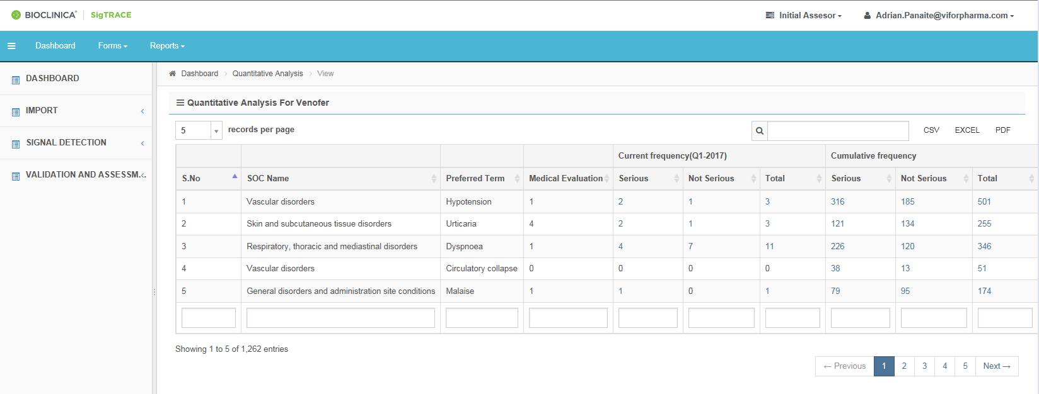 Quantitative Analysis is automated in SigTRACE and performed in line with the listedness of events and the thresholds for the number of reported cases (cumulative frequency):

**Workflow**

1= listed

2= infrequent

3= Safety observation

4= Synonym

0= Events not reported in the analyzed (current) period

NA = Special situations, non-evaluable events



* The Empty boxes in the last row can be used to filter for particular SOC, PT, Medical evaluation, etc. The initial assessor shall export the report in .pdf and .xls format and save it on the dedicated Signaling repository.

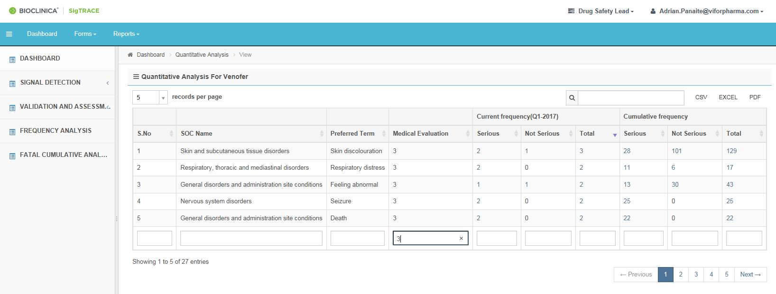

**Filter box**

1. The DSL should review the list and communicate to Bioclinica if for some PTs the codes 0 or 2 should be changed to code 3, in order to analyze these PTs during the period. If there are PTs with code 3 that should have the code NA/1 or 4, this should be communicated to the responsible functions to update the entries in the Synonym Lists.
2. After necessary changes are made, the DSL shall export the report in .pdf and .xls format, and save it on the dedicated Signaling repository

# Qualitative Analysis Workflow (Role: Initial Assessor, QC and DSL)

You can select analysis only for Current quarter or Cumulative period/ All cases

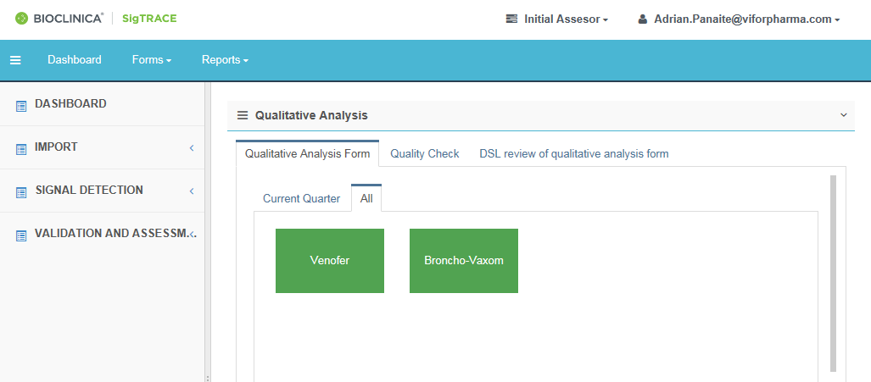

**Period**

**Workflow**

Process:

* Initial review (Qualitative analysis Form)
* Quality check
* DSL review of qualitative analysis form
* You can either select Qualitative workflow via select particular PT from Quantitave workflow, Or directly from Dashboard

**Option 1: To Select Qualitative Analysis workflow from Quantitative Analysis workflow**

1. Select the Product
2. Filter for Medical evaluation, preferred term, etc
3. Select the PT, click on number cases in Cumulative or Current Quarter.

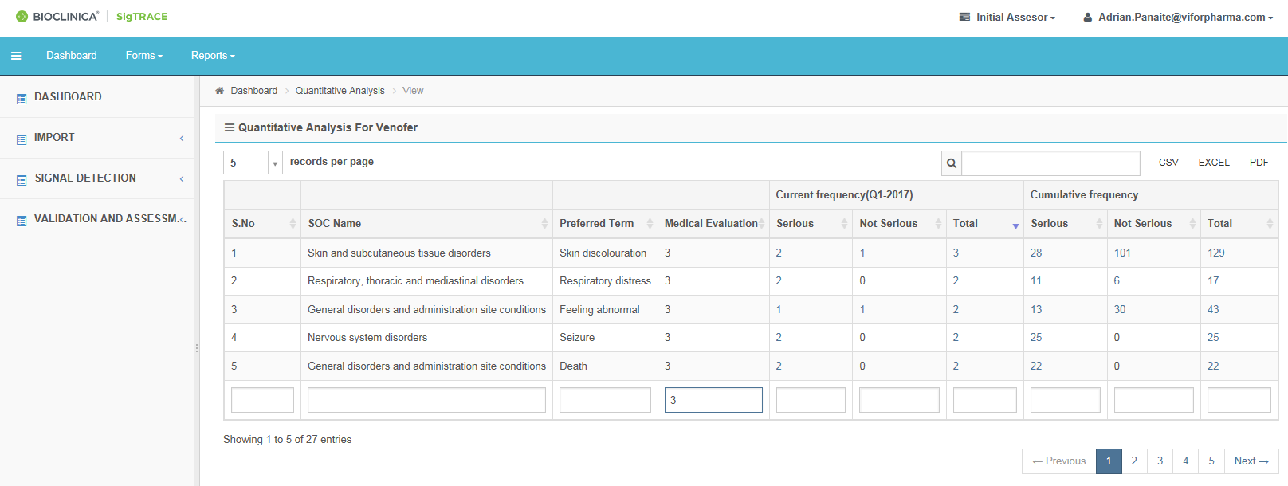

**Case Count**

**Case Count**

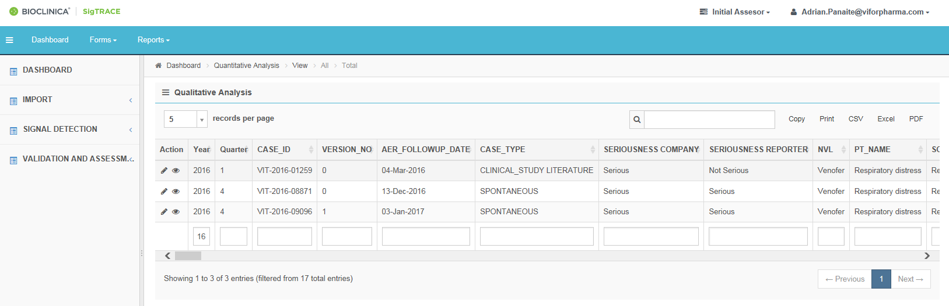

**Option 2: Select from the Dashboard / Qualitative Analysis**

1. Select Quantitative analysis form under Qualitative tab.
2. Select the period ‘**All**’ to see all cases pending for evaluation. Selection of the ‘**Current Quarter**’ will show only the cases pending for evaluation with reports during the quarter.
3. Select the Product



**4. Product**

**3. Period**

**2. Initial review**

**1.Workflow**

* All cases without a completed qualitative analysis will be displayed

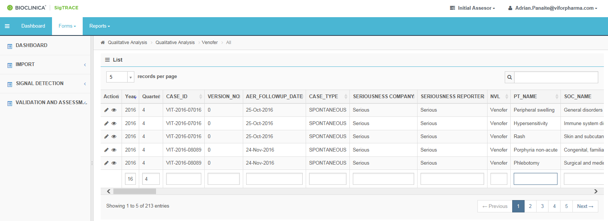

**2. Filter box**

**3. View**

**4. Edit**

**2. Search field**

**Items to be displayed per page**

**Qualitative Analysis**

* Select Number of searches to displayed per page: 5(default), 10,25,50, 100.
* Use Search field / filter box to search for particular case or PT, year, quarter, etc.
* Select  /View button to view case information (optional).
* Select /Edit button to edit the case and perform the evaluation
* After clicking on /Edit it opens case for qualitative analysis.
* It has case information about patient demographic, case level information about seriousness, all reported PT, lab data and case narrative.

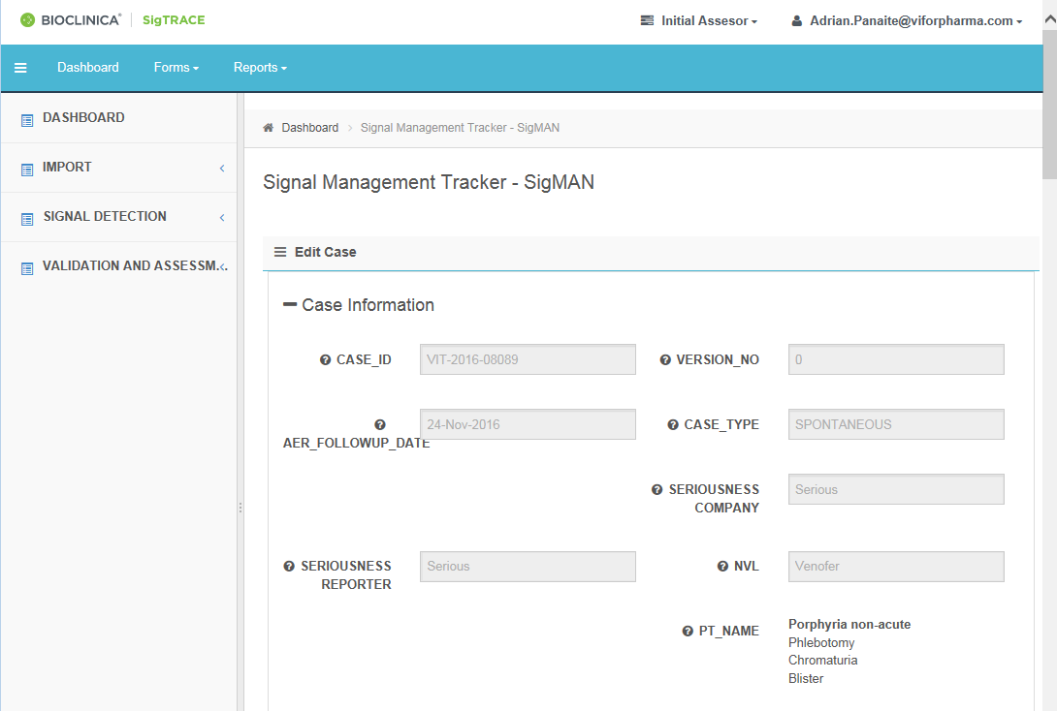

The Case primary information about patient demographics, Number of PTs,case seriousness and Case narrative is already pesent.

* PT of intrest is highlighted in Bold in list PT’s. (eg: Asthenia in above image).
* Floating above the  will display help inormation about the field

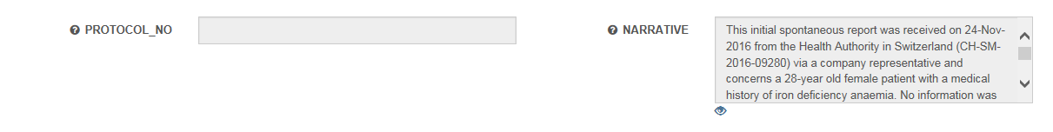

**Full narrative**

* Clicking on the  button will open in a new tab for the case narrative

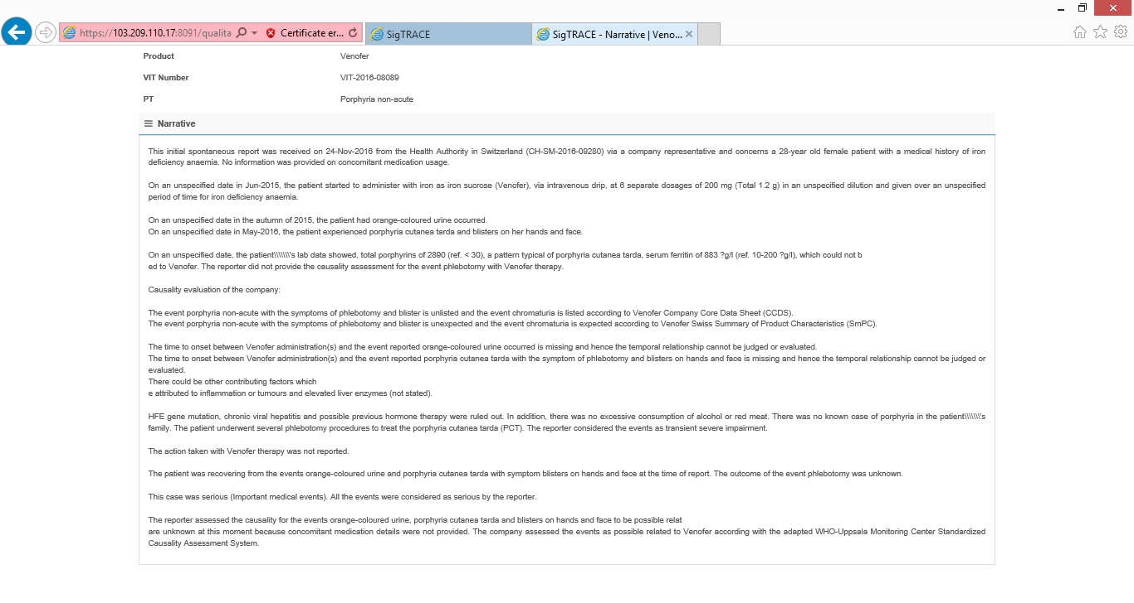

Qualitative Analysis



**1**

1. Select /Edit button to edit the case and perform the evaluation
2. To start Qualitative analysis, select Initial Assessment Start “Yes” from the dropdown
3. It will capture the Start date and Start time for Audit trail.
4. Select the appropriate dropdown/tickboxes in all relevant field.
5. Enter Comments manually in the respective fields provided.
6. To end initial Qualitative analysis for a case, select Initial Assessment Status “Complete” from the dropdown. Select “Pending” to perform analysis later.
7. It will capture the End date and time for Audit trail.
8. Click on Save at the end of the page.
9. It gives a pop out, select “Leave this page” to save the evaluation for that case or select “Stay on this page” to continue working on that case.

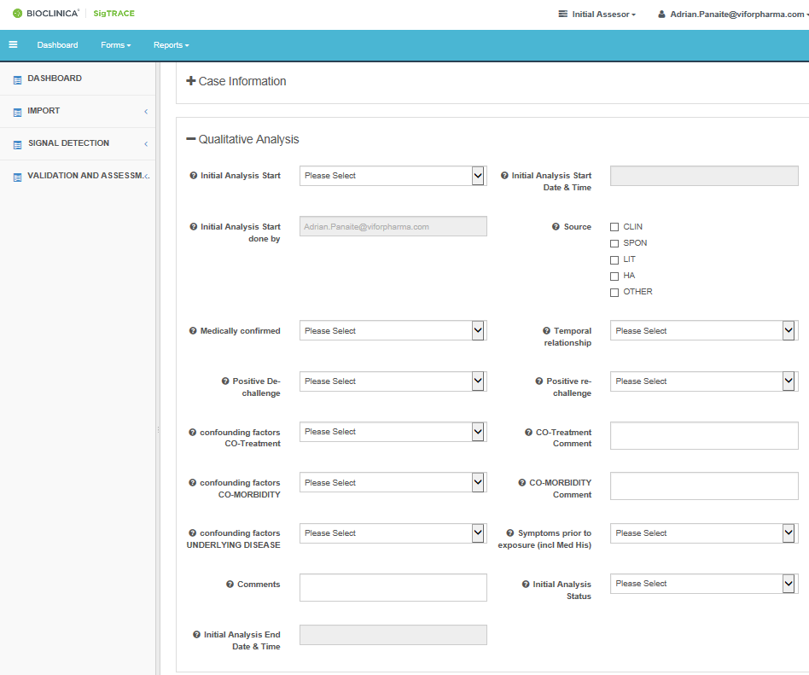

**2**

**7**

**6**

**5**

**4**

**3**

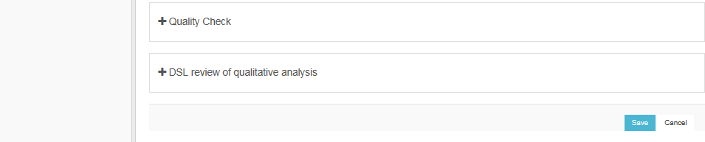

**8**

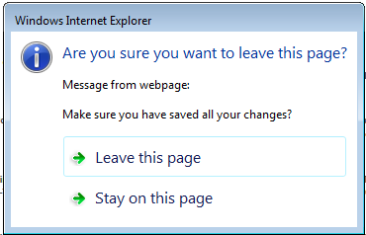

**9**

Quality Check (Role: Quality Reviewer)

1. Select Qualitative workflow from Dashboard
2. Select Quality check tab under Qualitative Analysis.
3. Select the Current Quarter or All for the period
4. Select the Product

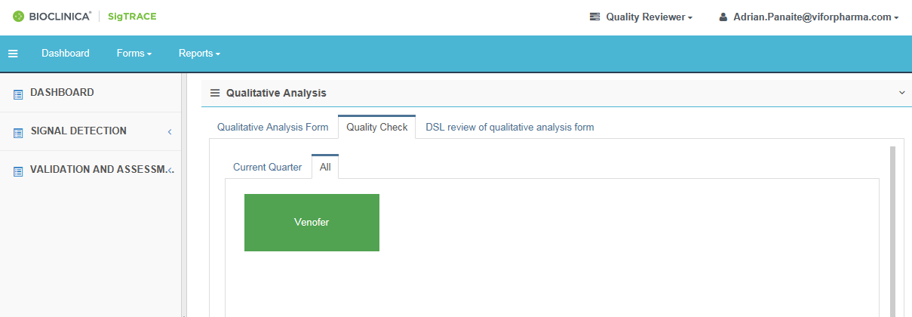

**4**

**3**

**1**

**2**

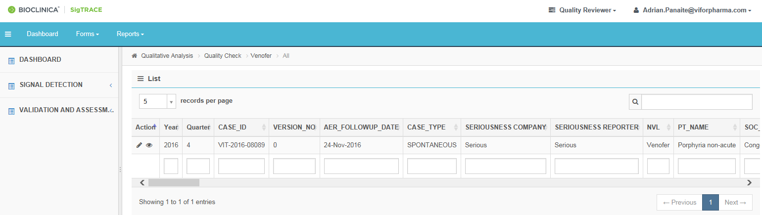

**5**

* Select Number of cases to be displayed per page: 5(default), 10,25,50, 100 (optional).
* Use Search field / filter box to search for particular case or PT(optional).
* Click  /View button to View case information (optional).

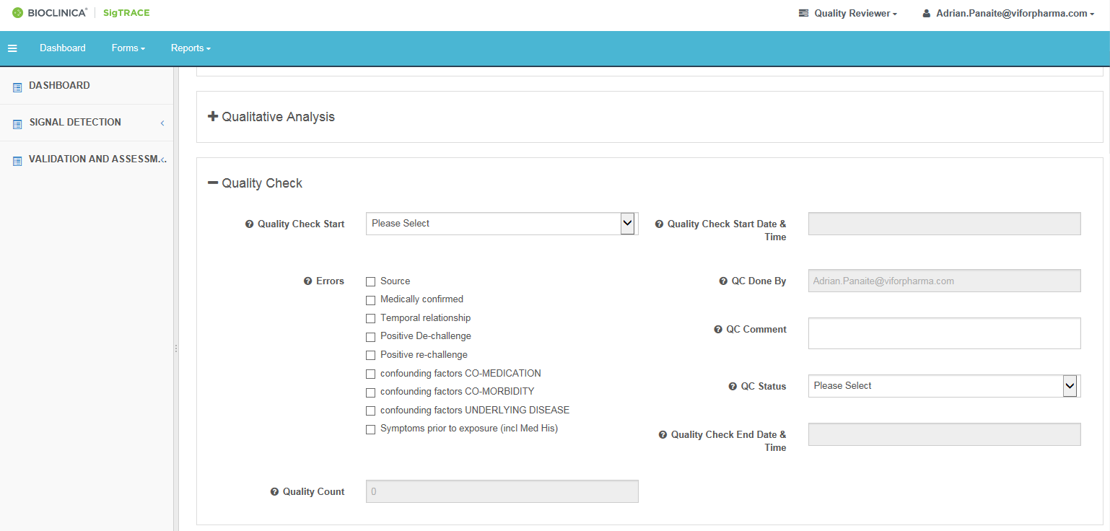

**12**

**11**

**10**

**9**

**7**

**6**

1. Click /Edit button to edit the case and perform the QC check.
2. To start Quality check, select Quality check Start “Yes” from the dropdown.
3. It will capture the Start date and Start time for audit trail.
4. Check the qualitative analysis and perform corrections as needed.
5. Highlight the fields with errors by checking the relevant boxes. The Quality count will decrease by 1 for each checked box.
6. Enter comments manually in the QC Comment field.
7. To end Quality check for a case, select QC Status “Complete” from the dropdown. Select “Pending” to perform analysis later.
8. It will capture the End date and End time for Audit trail.
9. Click on Save at the bottom of the page.
10. It gives a pop out; select:

* “Leave this page” to save the evaluation
* “Stay on this page” to continue working on that case.

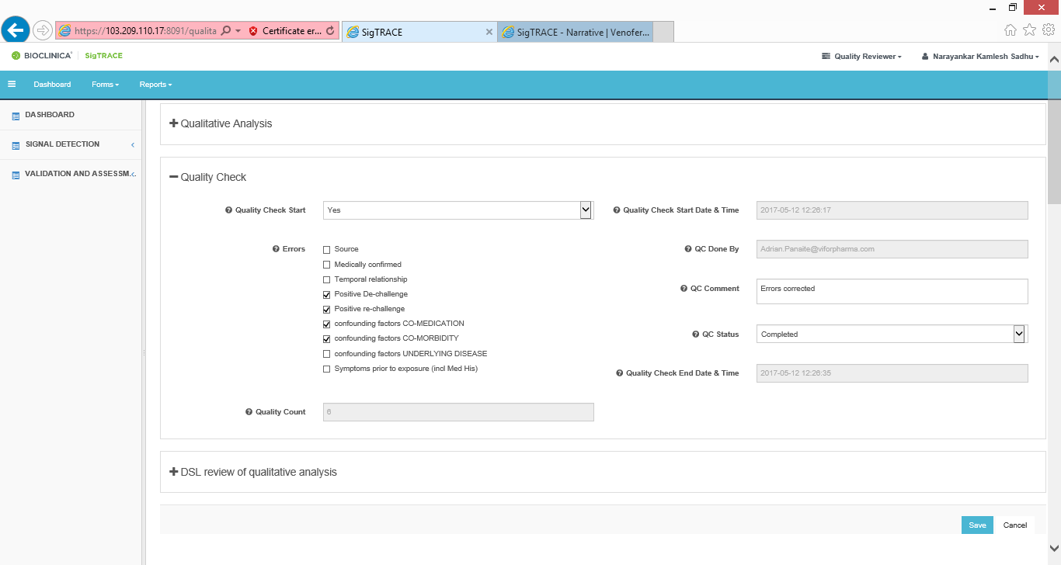

**13**

**12**

**11**

**10**

**9**

**7**

**6**



**14**

DSL review of qualitative analysis (DSL role):

1. To Select Qualitative workflow from Dashboard
2. Select DSL review of qualitative analysis from under Qualitative Analysis tab.
3. Select the period for evaluation: Current Quarter only or All pending
4. Select the Product; the pending cases for the selected period will be listed

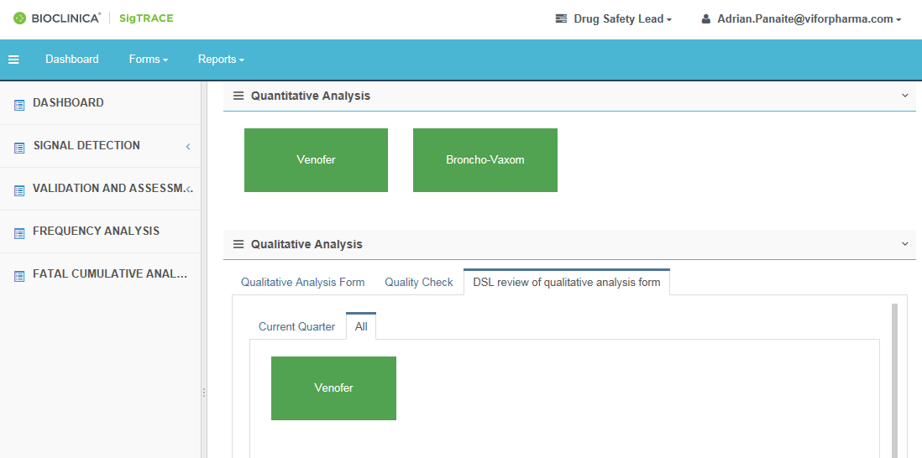

**2**

**1**

**3**

**4**

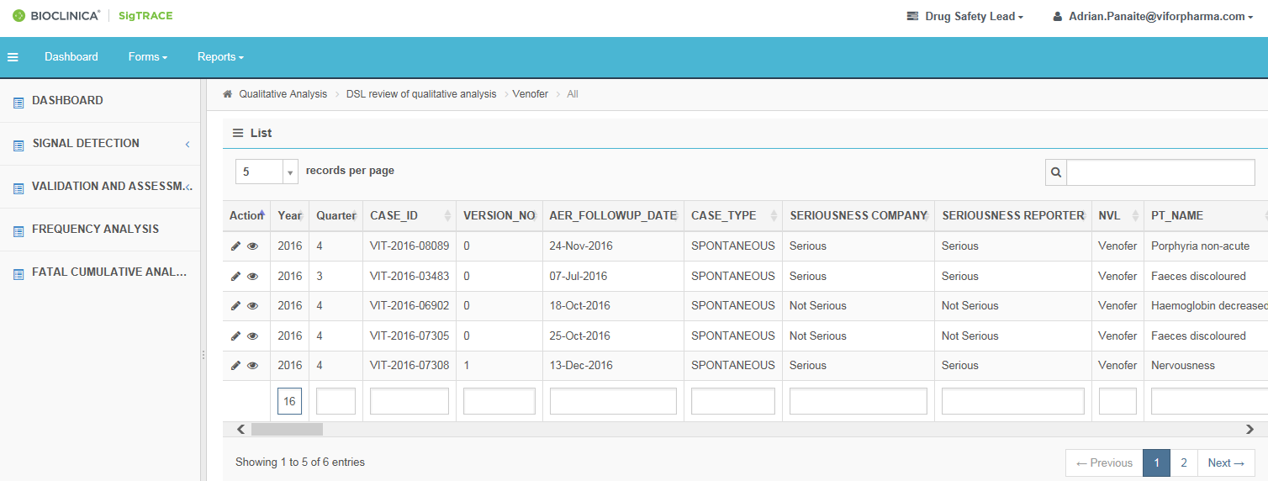

**5**

* Select Number of searches to displayed per page: 5(default), 10,25,50, 100 (optional).
* Use Search field / filter boxes to search for particular case, PT, year, etc (optional).
* Click  /View button to View case information (optional).

1. Click /Edit button to edit the case and perform the review.

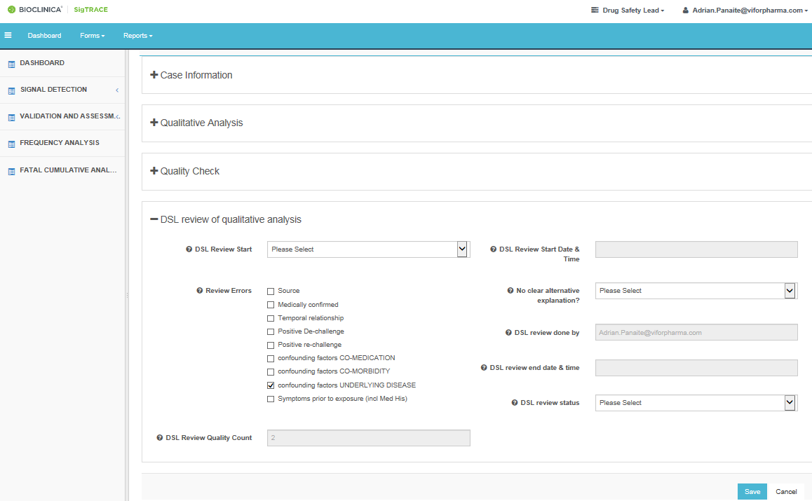

**13**

**12**

**10**

**9**

**7**

**6**

1. To start DSL review for case, select DSL review start “**Yes**” from the dropdown
2. It will capture the Start date and Start time for Audit trail.
3. Review the case and perform corrections as needed (note that in the accesible Case Information workflow the  button will open in a new tab the case narrative).
4. Highlight the fields with errors by checking the relevant boxes. The Quality count will decrease by 1 for each checked box.
5. Select the event has no alternative explanations from the dropdown signal dropdown.
6. If selected “**No**” tick the appropriate checkboxes .If selected “**Yes**” the list of codes will remain blank: the case should be discussed in the signaling meeting (potential index case).
7. To end DSL review for a case, select DSL review status from the dropdown:

* “**Pending**” to perform the analysis later
* “**Complete**” to finalize the analysis. It will capture the End date and time for Audit trail.

1. Click on **Save** at the end of the page.
2. It gives a pop out; select
   * “Leave this page” to save the evaluation
   * “Stay on this page” to continue working on that case.

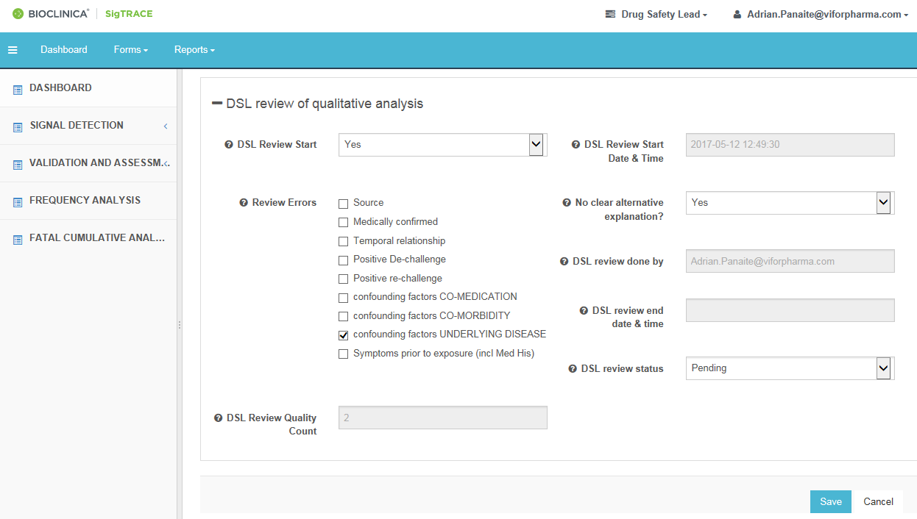

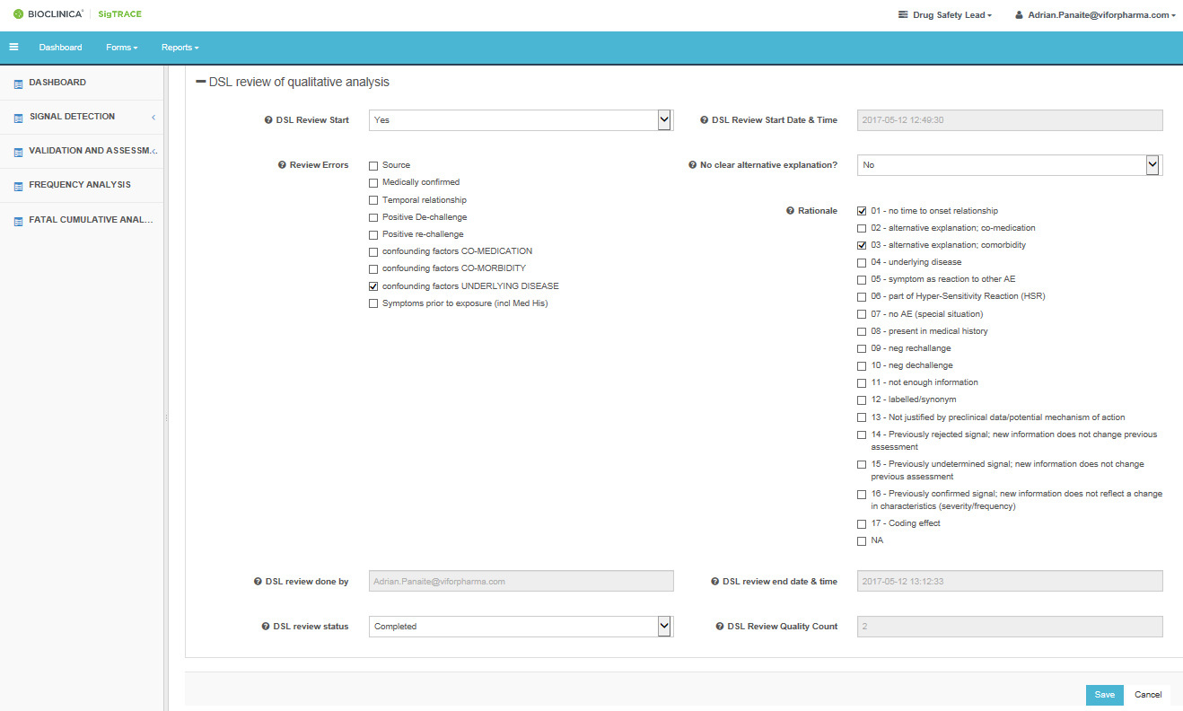

**11**



**14**

# Signal Detection Summary (Role: Quality Reviewer or DSL):

This workflow initiates the tracking of Safety observations (PTs/medical concepts) that will undergo validation evaluation.

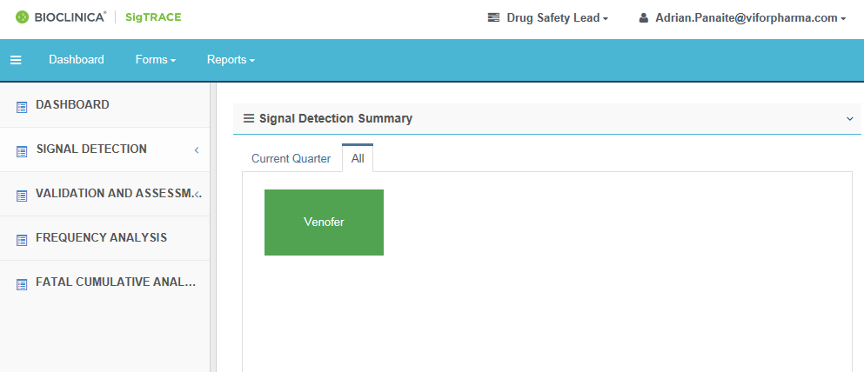

**1**

**3**

**2**

1. Scroll to signal detectection summary workflow from Dashboard
2. Select the Current Quarter or All pending for evaluation
3. Select the Product; it will list all pending Safety observations with completed qualitative analysis and review that need to undergo validation.

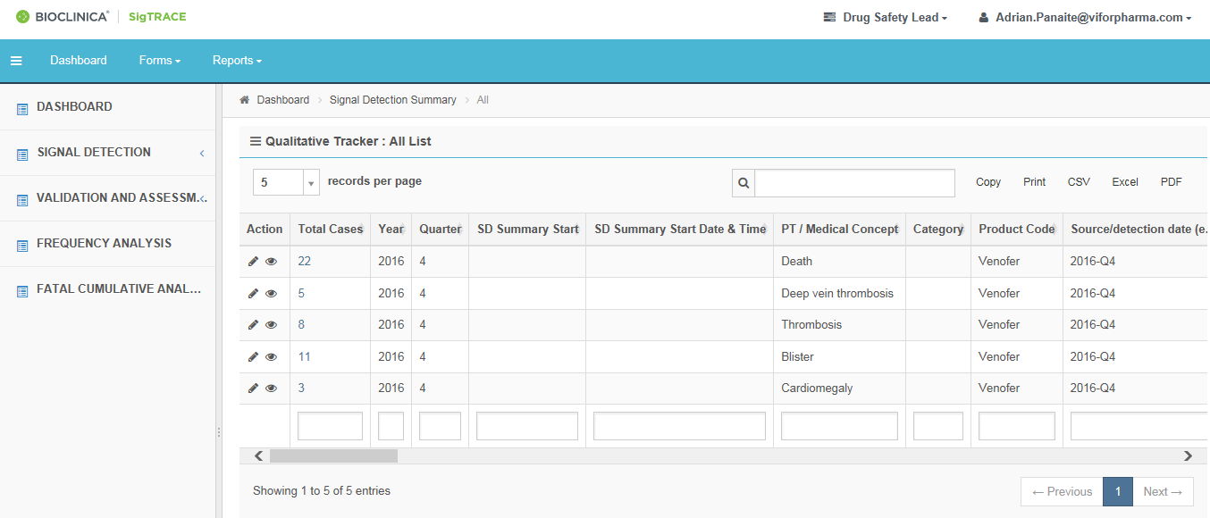

**4**

* Select number of records to be displayed per page: 5(default), 10,25,50, 100 (optional).
* Use Search field / filter boxes to search for particular PT, year, etc (optional).

1. Click on the number of Total cases shows you Qualitative analysis for that PT in qualitatibve analysis template. (optional).

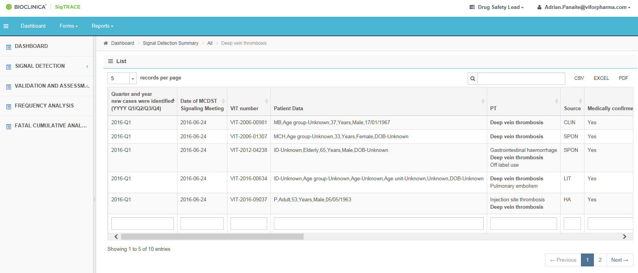

**All**

* The qualitative analysis template shall be exported to PDF, Excel or CSV and saved in the Signalling reporsitory. The information in the exporterd files can be for filling in the Signal Detection Summary, and afterwards the Validation workflow. Clicking on “All” in the address bar, or going back will revert to the previous list all Safety observations.
* 

**5**

* Click  /View button to View entry information information (optional).

1. Click /Edit button to edit the case and perform the review.

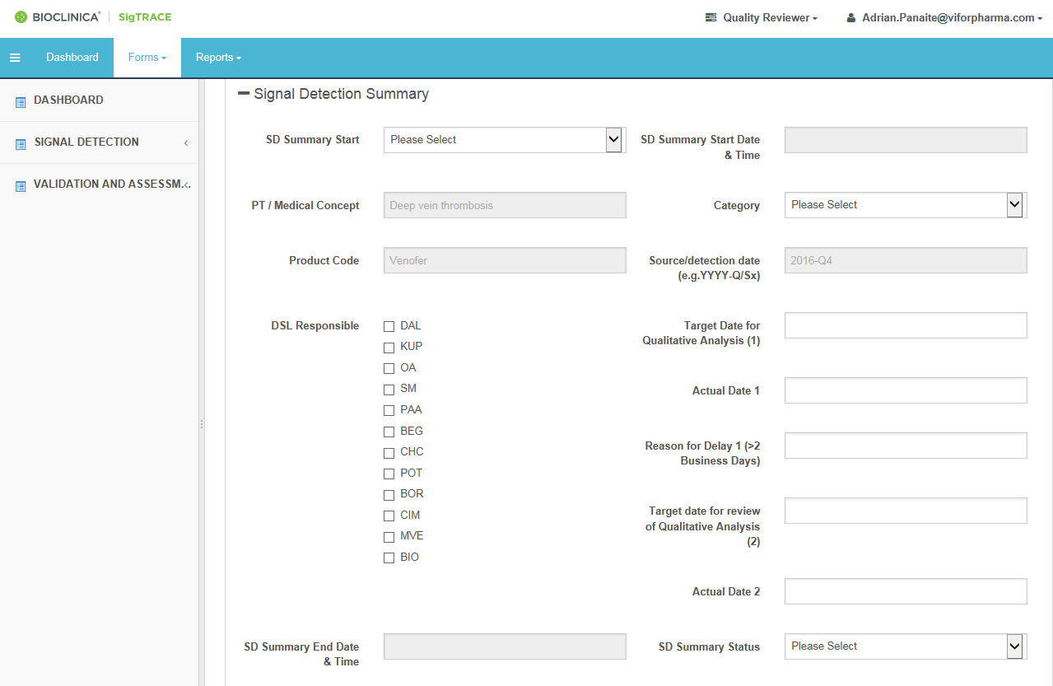

**6**

**8**

**7**

1. To start entering the data for the safety observation, select SD Summary Start “**Yes**” from the dropdown; it will capture the Start date and Start time for Audit trail.
2. Select the appropiate dropdowns / enter the appropriate data.
3. Select SD Summary Status from the dropdown:
   * “**Pending**” to complete the data entry later
   * **“Complete**” finalize the data entry; it will capture the End date and time for Audit trail.
4. Click on **Save** at the bottom of the page.
5. It gives a pop out, select **“Leave this page”** to save the evaluation and push the Safety observation to the validation workflow, or “**Stay on this page**” to continue working



**10**

# Validation (DSL):

1. Scroll to Validation workflow from Dashboard

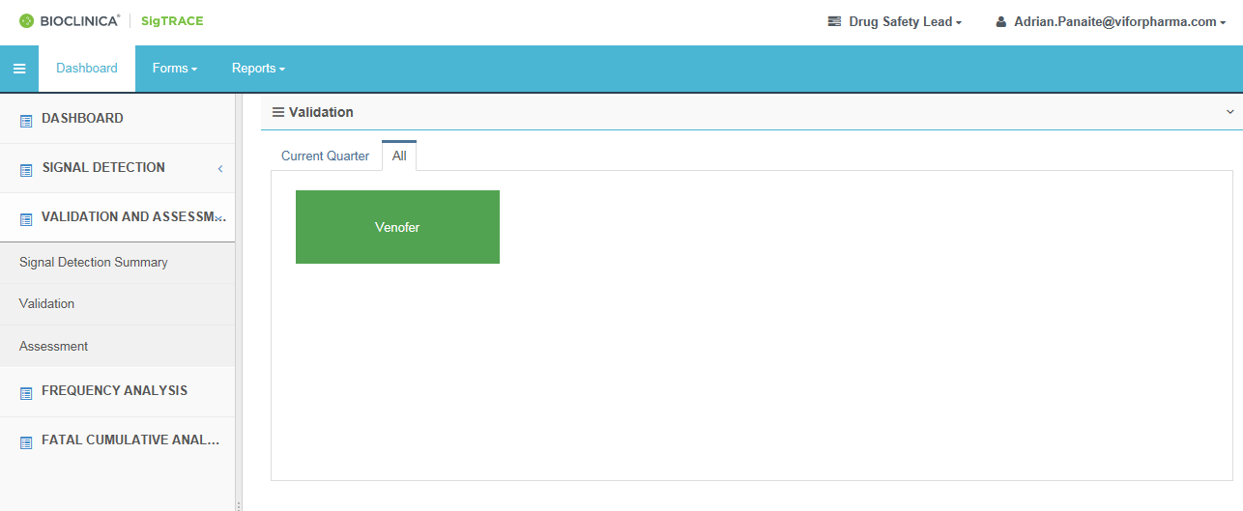

**Product (3)**

**Period (2)**

**Workflow (1)**

1. Select the period All to see the pending Safety observations
2. Select the Product: It will list the Safety observations pending validation.

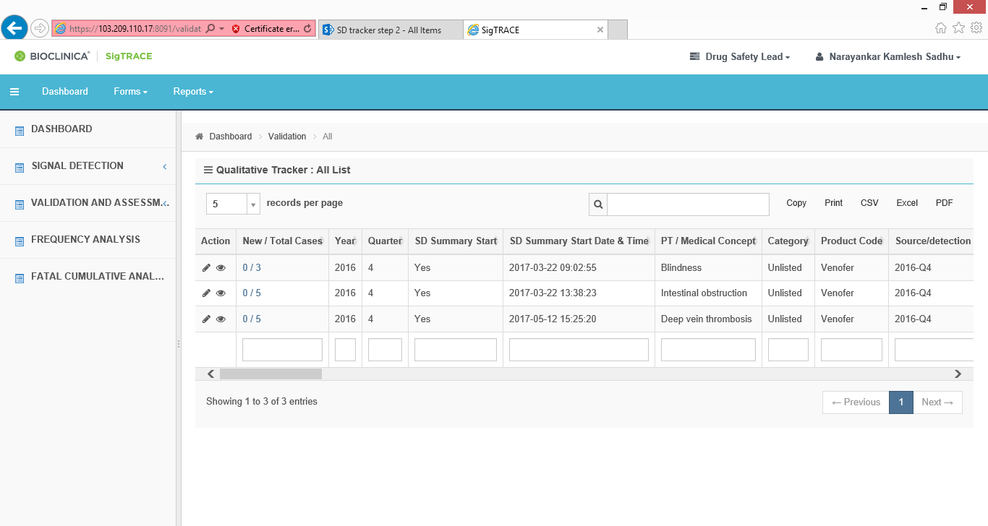

**4**

* Clicking on the number of Cases (new/total) shows you Qualitative analysis for that PT in Signal assessment template in a new tab. You can choose to export it to PDF, excel or CSV (Optional). Clicking on “All” in the address bar or going back will revert to the previous list all Safety observations.

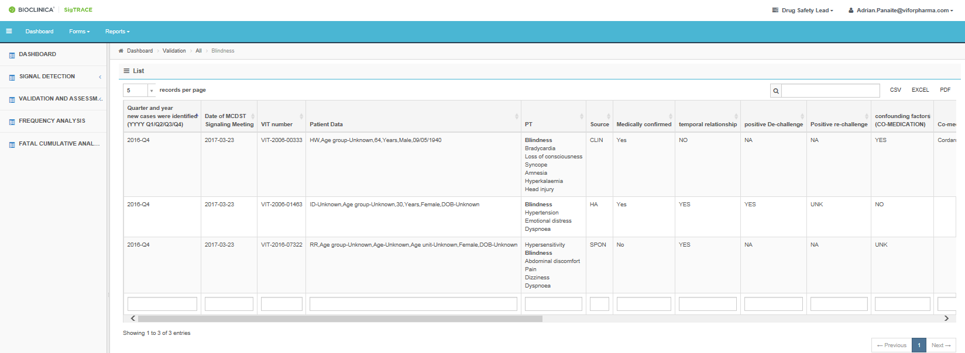

1. Clicking on /**Edit**, opens workflow for analysis.

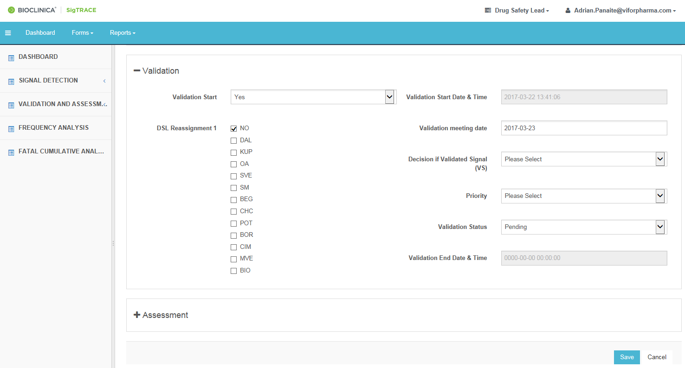

**7**

**6**

**5**

1. To start DSL review for PT Validation, select Validation start “**Yes**” from the dropdown
2. It will capture the Start date and time for Audit trail.
3. Select the appropiate dropdowns.
4. Decision if validated signal:
   1. Select “**Yes**” for validated signals, and select the priority A or B.
   2. Select “**No**” to not validate, and tick the rationale codes for the new cases.

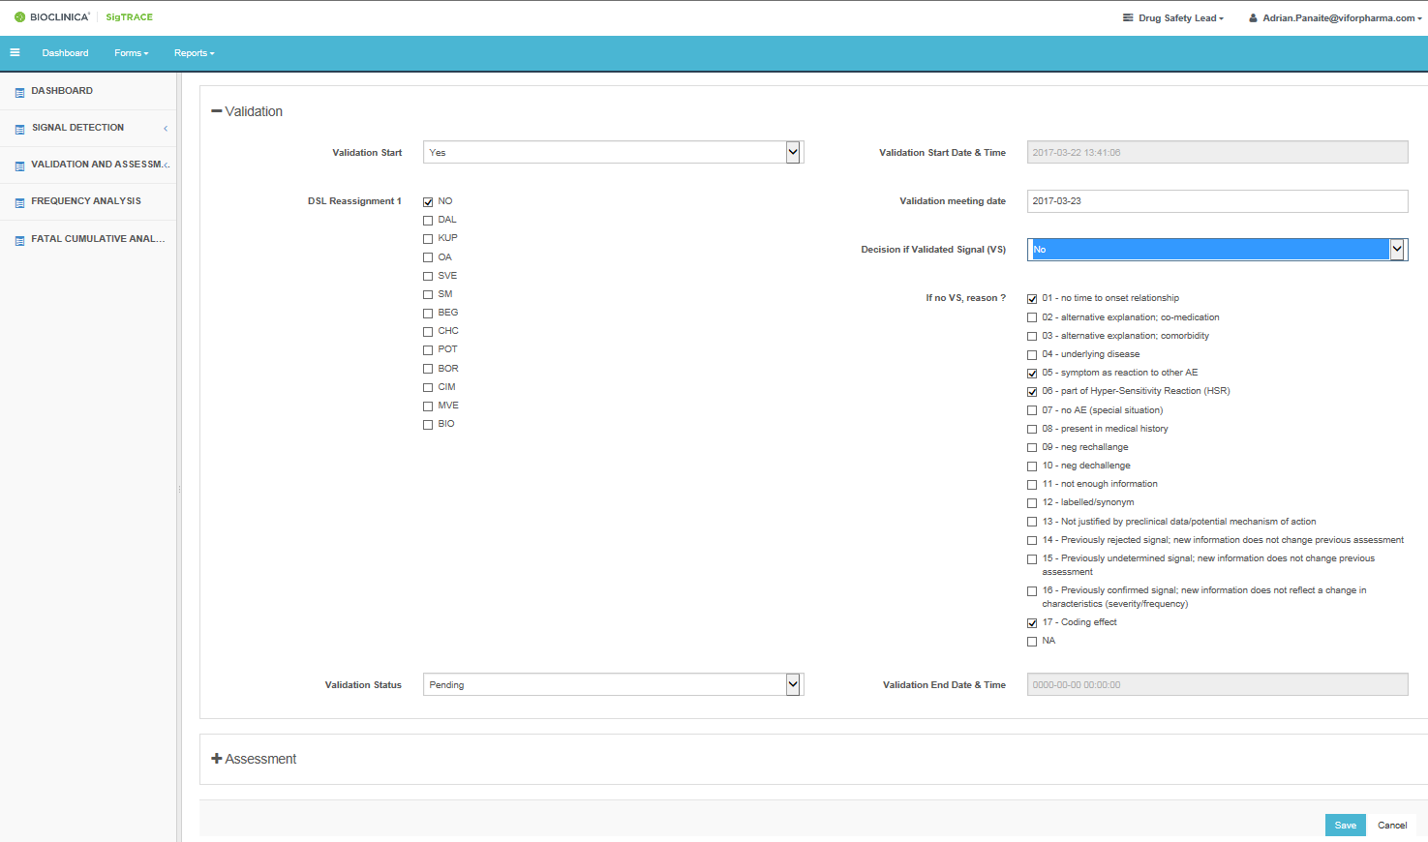

**9**

**8**

1. Validation process completion:
   1. Select “**Pending**” in preparation to the signaling meeting and click on **Save**.
   2. Select Validation Status“**Complete**”, after the safetay observations were discussed in the Validation meeting; it will capture the End date and time for Audit trail. Click on **Save** at the bottom of the page.
2. It gives a pop out, Select “**Leave this** **page**” to save the entries or Select “**Stay on this page**” to continue working.

# Assessment (DSL assessment):

**10**

This workflow tracks the main points of the assessment of the Validated Signals, and record the decisions regarding the main actions.

1. Scroll to Assessment workflow from Dashboard

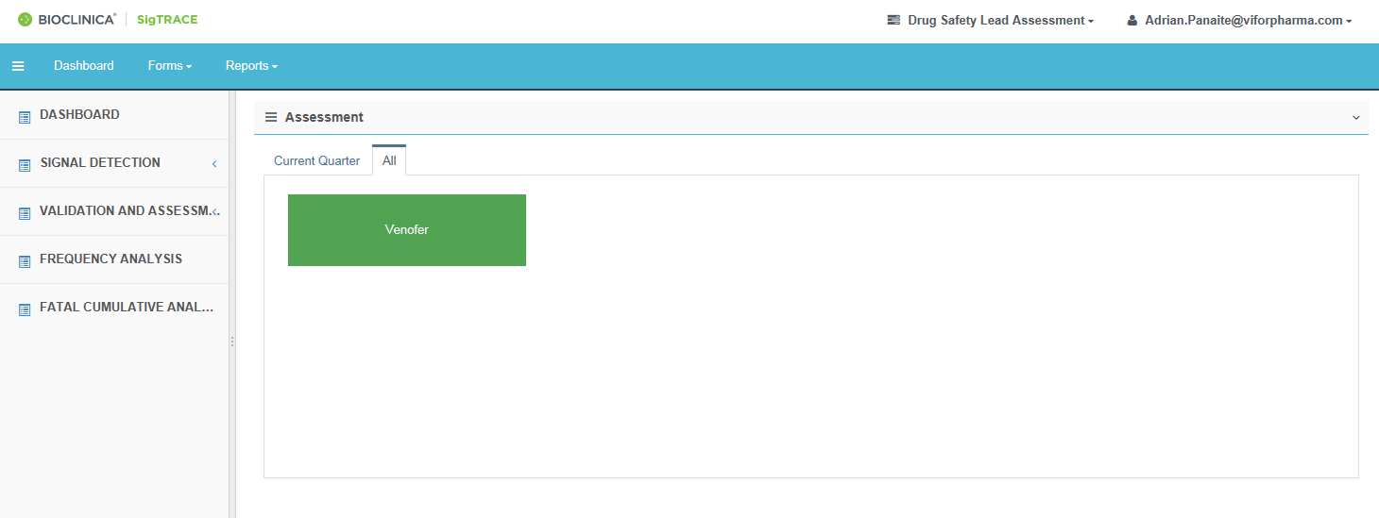

**Product (3)**

**Period (2)**

**Workflow (1)**

1. Select the Current Quarter or All for the period.
2. Select the Product; it will list all validated signals for the product with ongoing assessment.

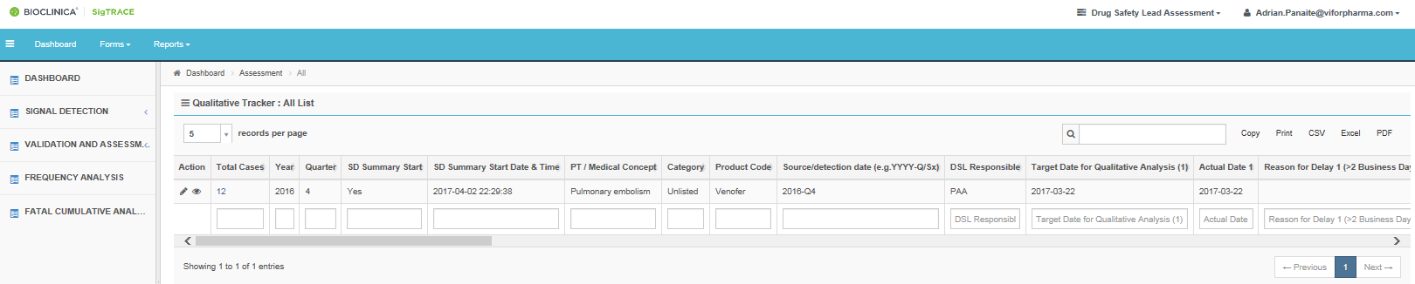

* Scrolling to the right will show all tracked items for the assessment and action.
* Clicking on the number of Total Cases shows the Qualitative analysis form for the post-marketing cases that were evaluated and led to the validation of the Signal. You can choose to export it to PDF, excel or CSV (Optional). Clicking on “All” in the address bar or going back will revert to the previous list all signals under assessment.

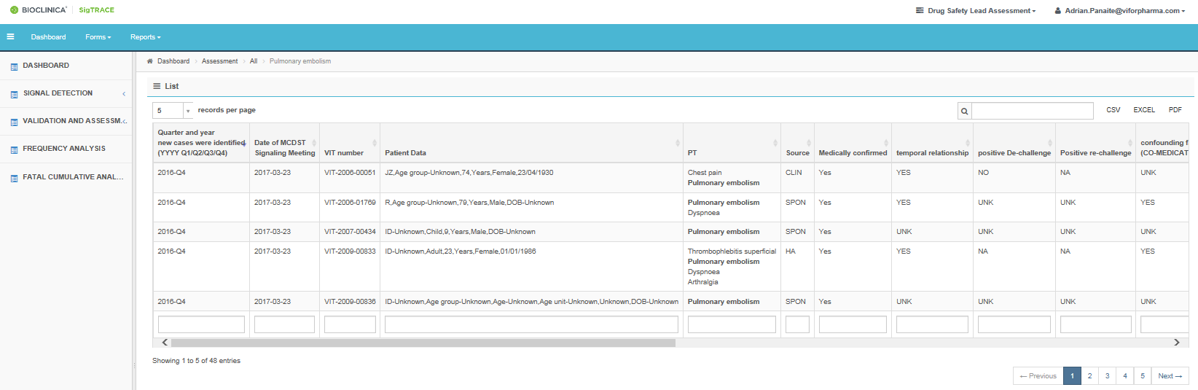

1. Clicking on /**Edit**, opens workflow for tracking.



**4**

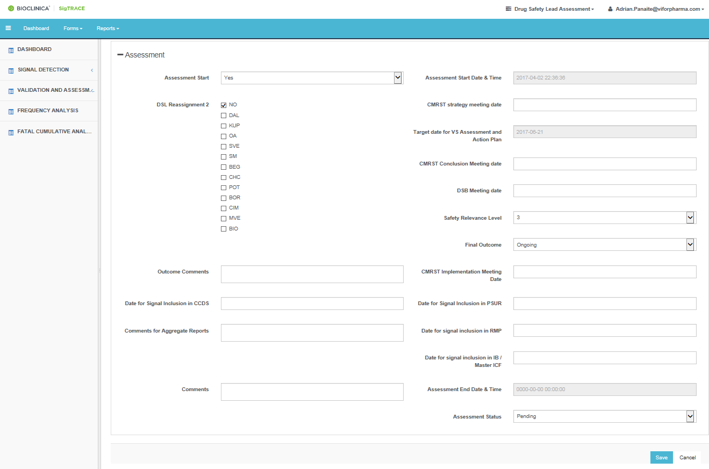

**8**

**7**

**6**

**5**

1. To start Signal Assessment, select Assessment start “**Yes**” from the dropdown; it will capture the Start date and time for Audit trail.
   * The target date for the finalization of the assessment is automatically calculated based on the date of the Validation meeting date and the priority (A or B)
2. Select and fill the appropiate dropdowns/tickboxes/dates/comments based on the CMRST/DSB decisions or scheduled timelines.
3. Assesment status from dropdown:
   * Select “**Pending**” until all actions are still to be performed or decided upon.
   * Select “**Complete**” at the end of the assessment (including decisions on action plan). It will capture the End date and time for Audit trail
4. Click on **Save** at the end of the page.



**9**

1. It gives a pop out, Select **Leave this page** to save the evaluation for that case or Select **Stay on** **this page** to continue working on that case.

# Report generation

All users can generate reports from SigTRACE.

The following reports can be generated (Click on reports in the menu bar):

* Click on the desired report. The list of filters to be selected for the reports will appear

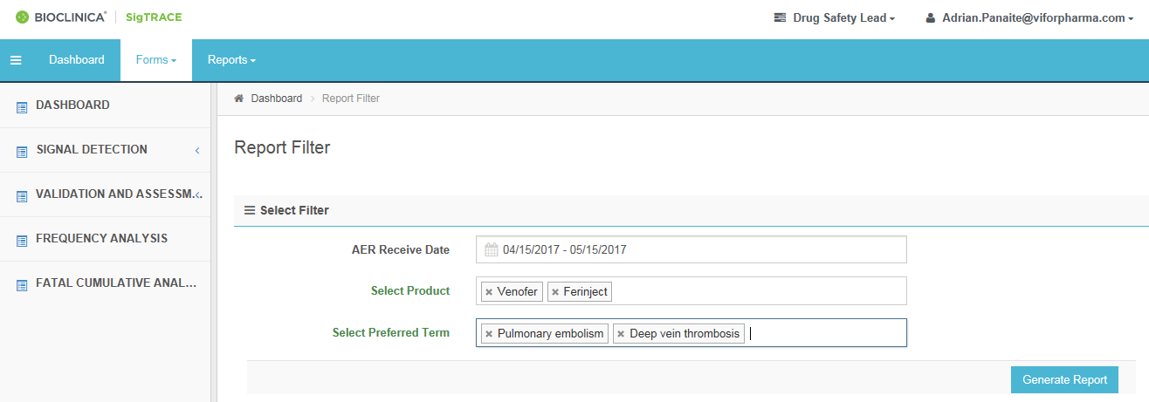

**Generate Report**

* Select the appropriate parameters for the report. Note that more than or product or term can be selected. Leaving a filter blank will consider all possible entries (longer time for generation are to be expected).
* Click on Generate report. The report will be displayed on screen and can be exported in CSV, EXCEL and PDF format.

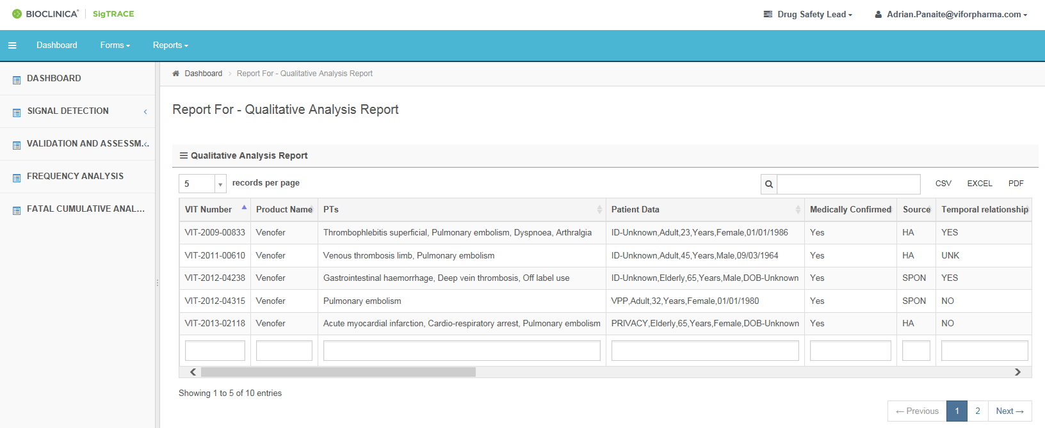

* The exported forms will have the following type of Header, and can be stored in the appropriate repository.

The content of the reports are as follows:

1. List All
   * The report contains full latest case information and analisys, using filters for period, product and PT. To be exported as Excel only.
2. Qualitative analysis report
   * The report contains qualitative analisys, using filters for period, product and PT.
3. Status report
   * The report contains the status for selected PTs/safety observations in various workflows for the Signal detection, validation and assessment activities
4. Metrics signal validation and assessment
   * The reports shows if the assessment of the validated signals was done on time.
5. Signal Sharing Listing
   * The report list the signals with an ongoing or closed assessment activity during a certain period
6. Overview of Validated Signals
   * The report show the distribution of validated per outcome and product for the validated signals.
7. Metrics Signaling qualitative analysis
   * The reports shows if the signal detection activities were completed on time (beta version).
8. Overview of Validated Signals (%)
   * The report show the proportion of validated per outcome and product for the validated signals.
9. Overview of validated and non-validated signals
   * The report show safety observations entered in the signal detection summary and validation, with possible filters for period, product, and validation result (Old SD tracker step 2)



















# Administrative tools (Administrator)

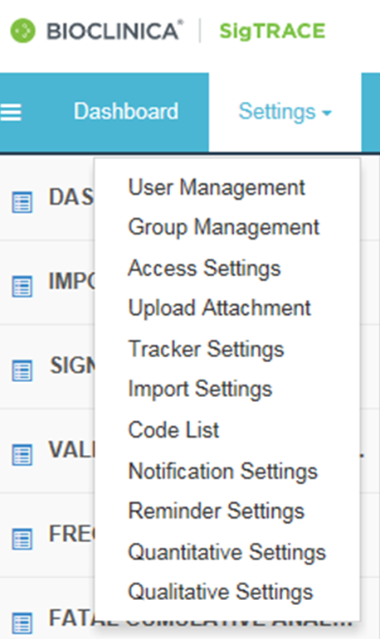 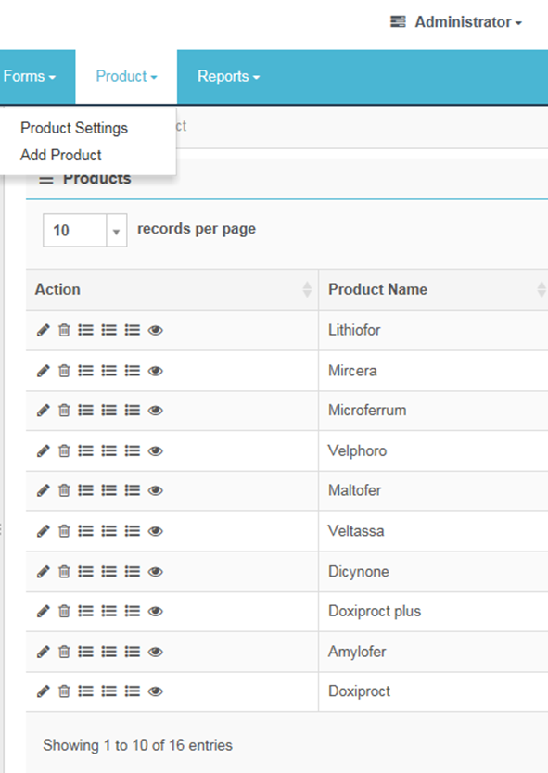

* User list
* Access rules
* Possible field entries
* Fields mapping
* List of product
* Listed / synonyms / special situations events